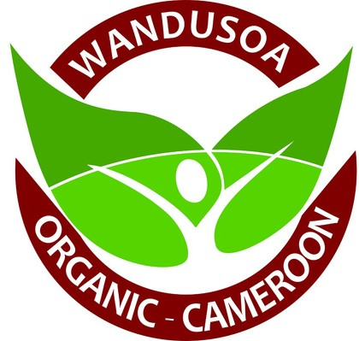
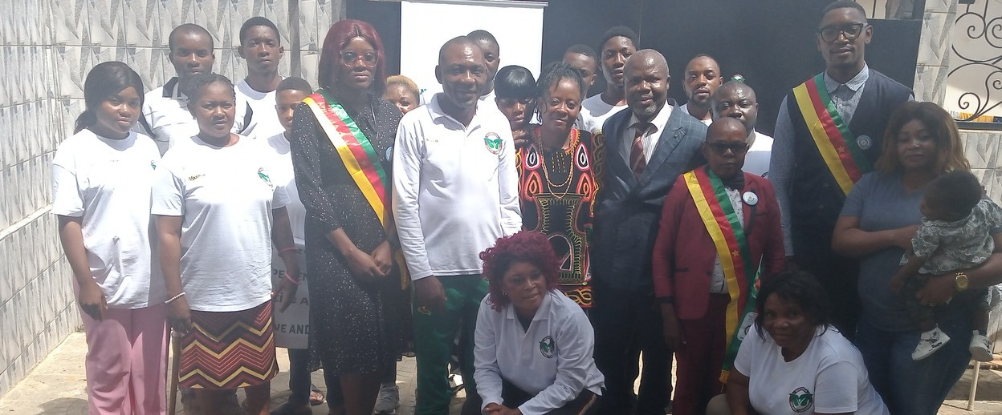

WANDUSOA 2ND QUARTERLY NEWSLETTER
APRIL-JULY 2023

REGENERATIVE NEWS

Dear friends and supporters of Wandusoa,
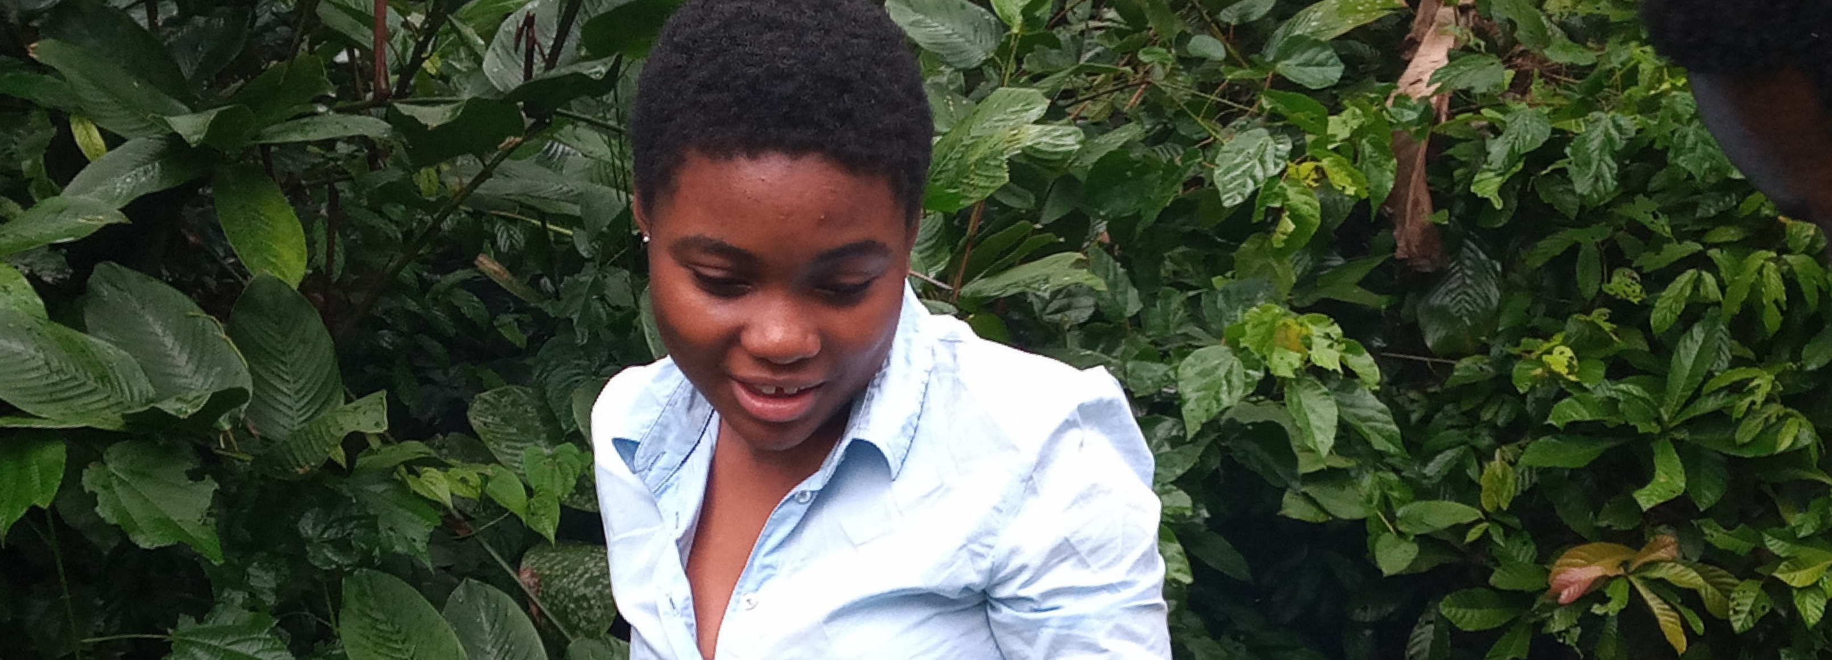
The Second Quarter of 2023 for Wandusoa has been an exciting and busy one. We are pleased to receive two Kanthari Alumni, three Junior Senators, and Senior Officers of the Regional Delegation of the Center Region of Cameroon on our premises and farm. Beneficiaries also started reaping the fruits of their labor. It is our harvesting season. The highlight of this second quarter of the year is the Training workshop on the Transformation and Preservation of food in partnership with the PEACE CROPS organization in Cameroon. Please read, enjoy, and share with friends, families, and your networks.
MAKING TOPSOIL FERTILE AND HARVESTING HEALTHILY.

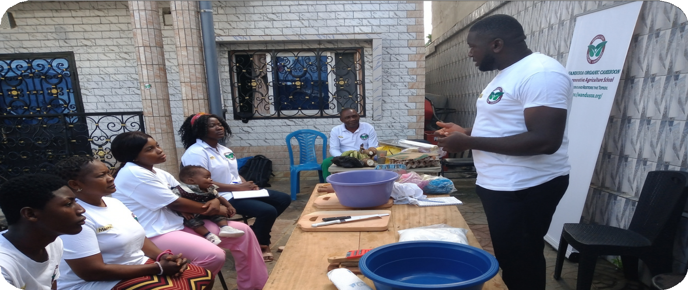
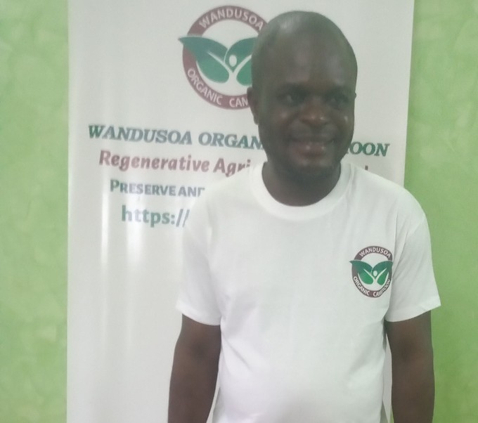
VISIT OF TWO KANTHARI ALUMNI

Teh Francis is a kanthari Course Alumni 2016 and the Director of Goodness and Mercy Missions; The GMM EnKindle Cameroon Project. Wandusoa expresses gratitude to Teh Francis for his inspiring one-week working visit in June 2023. This visit has nursed courage, hope, and steadfastness in all the Wandusoans
1

JOSHUA TRAINING WANDUSOANS

Joshua Njeke is the founder/Director of PEACE CROPS Cameroon a kanthari Alumni and kanthari Act 5 mentor for Wandusoa. He paid a working visit on June 6th, 2023 to conduct a Food Processing and Transformation Workshop with our participants as his physical contribution to our collaboration in The Pollination Project Greenhouse Grant.

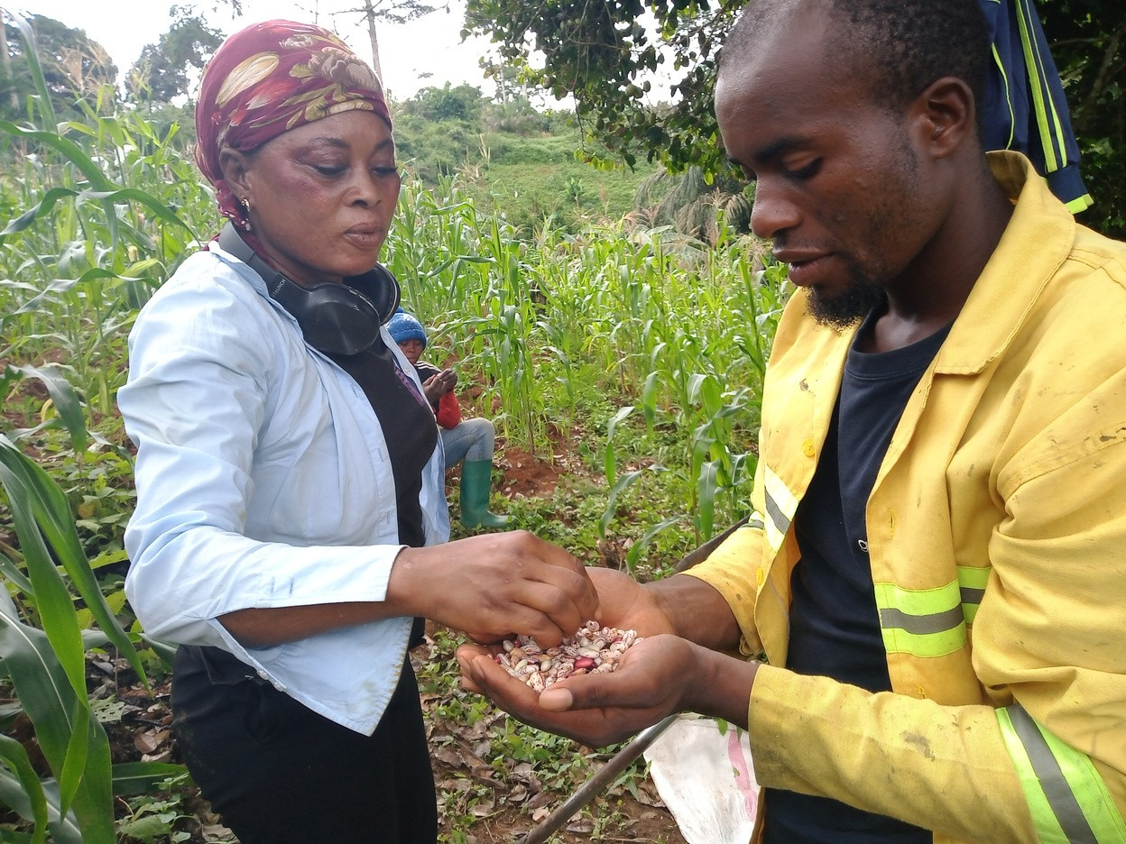
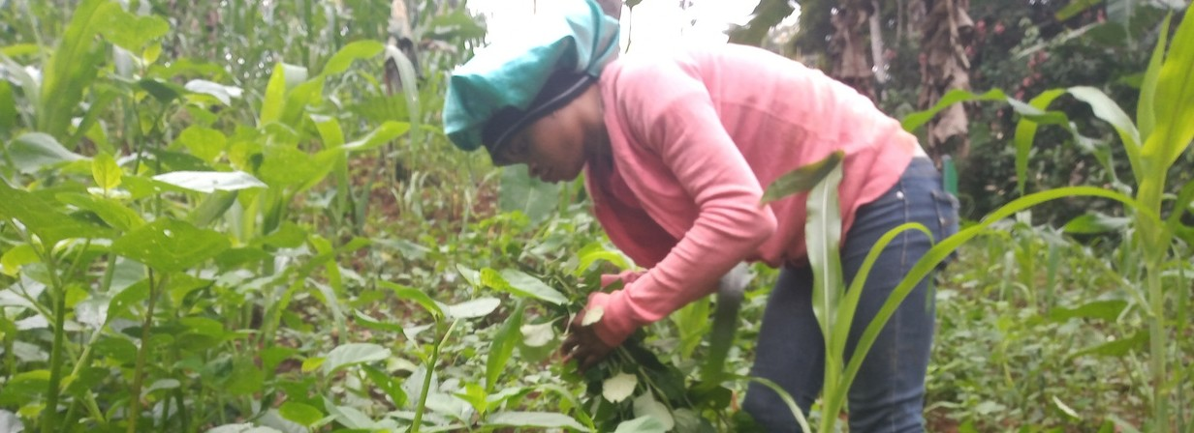
Our vision to preserve and restore topsoil

HEALTHY TOPSOIL GAURANTEES HEALTHY FOOD-

needed for all species to survive guides

HEALTHY PEOPLE-HEALTHY PLANET. 2

us to become conscious food producers and a member of The Conscious Food Systems Alliance (CoFSA). Here, we collectively develop the Inner Capacities for Regenerative Food Systems.

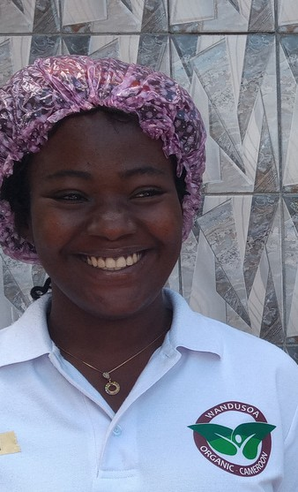
Please, stay tuned to our project progress updates in our weekly blog posts. YOUR DONATION

MAKES A DIFFERENCE !
With your donation, you support the training of marginalized persons that enables them to become socially, and ecologically responsible rural entrepreneurs. Your donation has an impact over many years and reaches countless people in need around the world and also healing our planet. You can donate here: https://www.omprakash.org/wandusoa/2024 or through our Bank Account.
Bank Name: Afriland First bank.
Account Name: Wandusoa Organic Cameroon Development Association. Swift Code: CCEICMCX
IBAN Code: CM21 10005 00034 08418321001-55.
For collaboration, please contact: info@wandusoa.org, Tel: +237653824721 . Visit our website: https://wandusoa.org/ Thank you!

